To,

Dr. Kavita Khanna

Head of Department

Computer Science Engineering

The NorthCap University, Gurugram

Haryana – 122017

Date: June 4, 2018

Subject: Request for grant of funds for infrastructure project

Respected Ma’am,

This is with regards to University Infrastructure Committee Project – “Venue Booking System”, wherein an **RFID Based Door Lock System** was stated as requirement for venues booked through the online web portal. Hence, keeping in view of the above, we propose the required hardware with their specifications below for the same.

Thus, we would like to request the University to kindly grant us the funds requested below for the smooth implementation of the project. Looking forward for your support.

Thanking You.

Yours affectionately

Jatin Singh Bhati (15CSU085)

Jogender Singh Yadav (15CSU087)

Vishesh Tandon (15CSU271)

(Department of Computer Science Engineering)

The NorthCap University, Gurugram

**Hardware Requirements & Specifications:**

1. C3 200 Pro – Door Access Controller

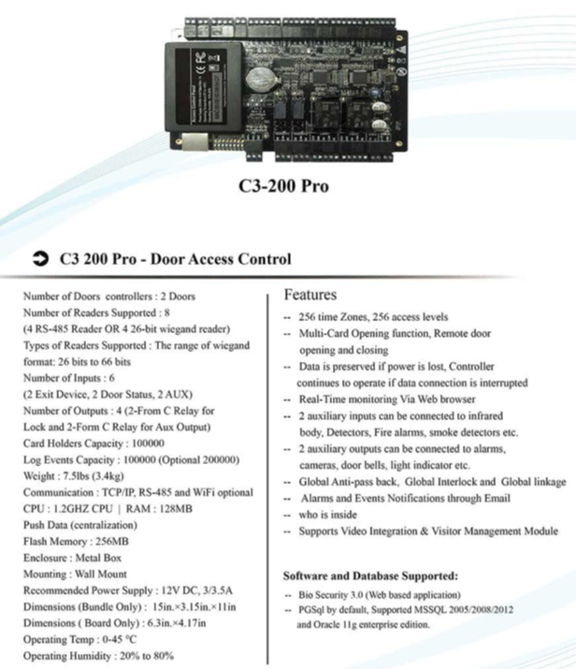

1. KR500 E/M – Card Reader

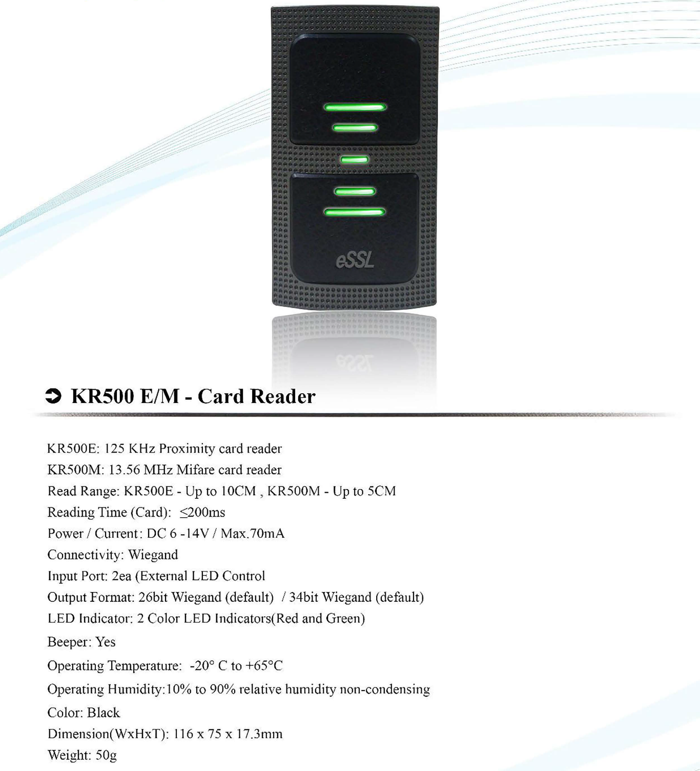

1. RFID Card

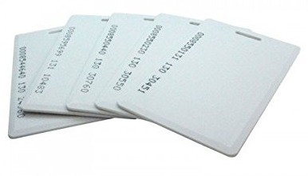

**Project Quotation:**

|  |  |  |
| --- | --- | --- |
| **S.No.** | **Particulars** | **Rate (INR)** |
| 1. | C3 200 Pro – Door Access Controller | 17,500.00 |
| 2. | KR500 E/M – Card Reader | 1,200.00 |
| 3. | RFID Card | 20.00 |
| 4. | Installation Charges | 3,000.00 |
|  | Total | 21,720.00 |